CS 4649 – RIP
Group Homework 2: Motion Planning

Inder Dhir, Ajmal Kunnummal, Sagar Laud, James Liu, Richard Stauffer
11/10/14

Question 1: Navigation Planning - Bug Algorithms for Point Robot
Part a)
Bug1 on Domain1
Euclidean = 200.56
Total Distance = 604.33
Ratio = 3.01322

Bug1 on Domain2
Euclidean = 140
Total Distance = 1926
Ratio = 13.75714

Part b)
Bug2 on Domain1
Euclidean = 200.56
Total Distance = 261.37293
Ratio = 1.3032

Bug2 on Domain2
Euclidean = 140
Total Distance = 3702
Ratio =26.4428

Question 2: Navigation Planning - Potential Field Navigation for Point Robot
Part a)
Euclidean = 200.56
Total Distance = 229
Ratio = 1.1417




Part b)



Question 3: Manipulation Planning - Differential Kinematics
Part a) Refer to the video “3a Video.mp4” for the video of the arm as it moves from initial to goal pose.
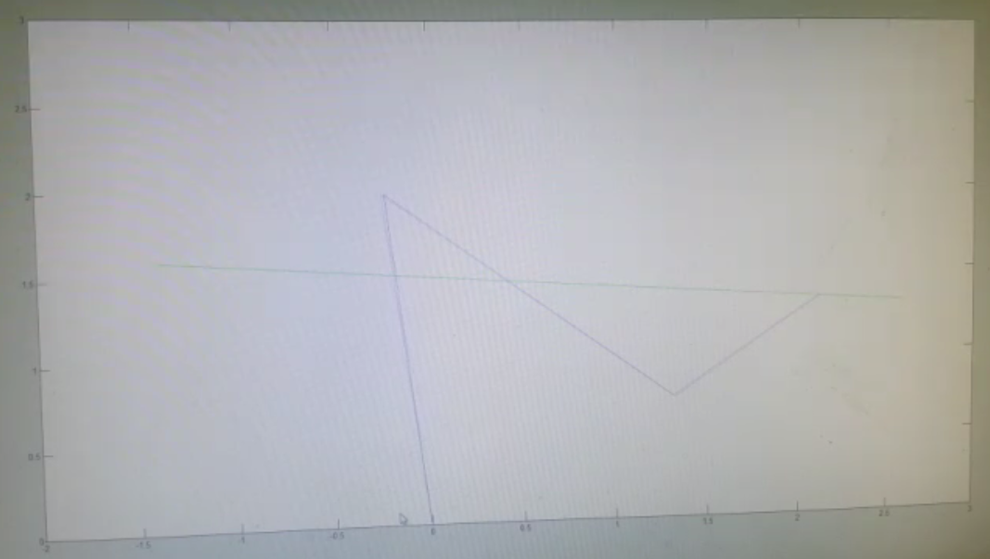
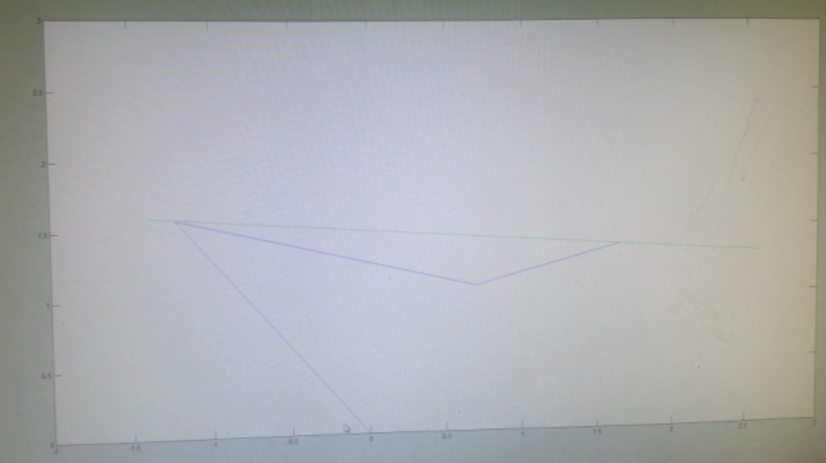

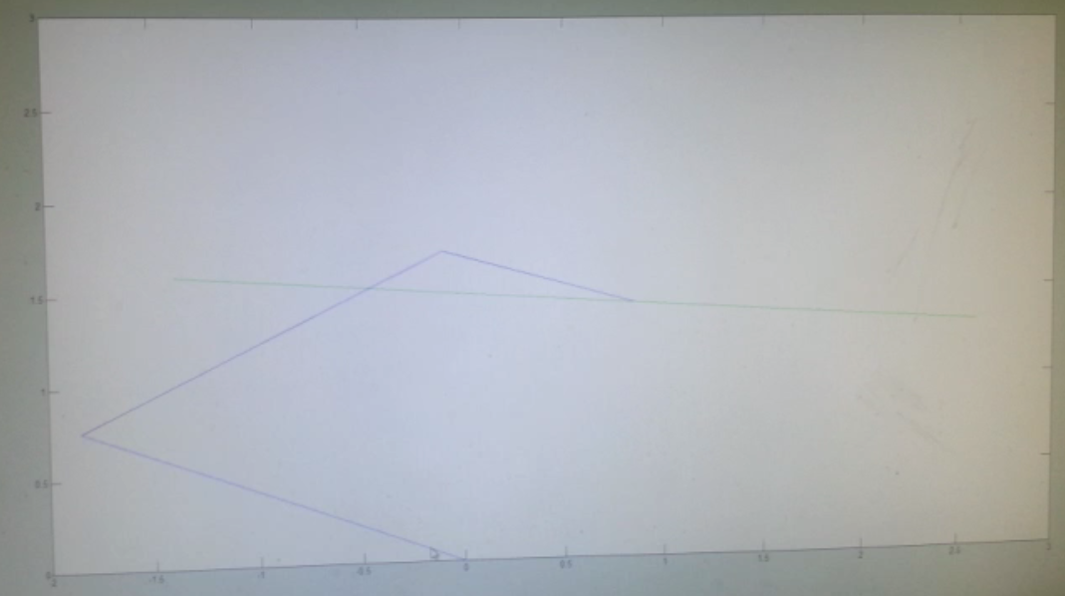
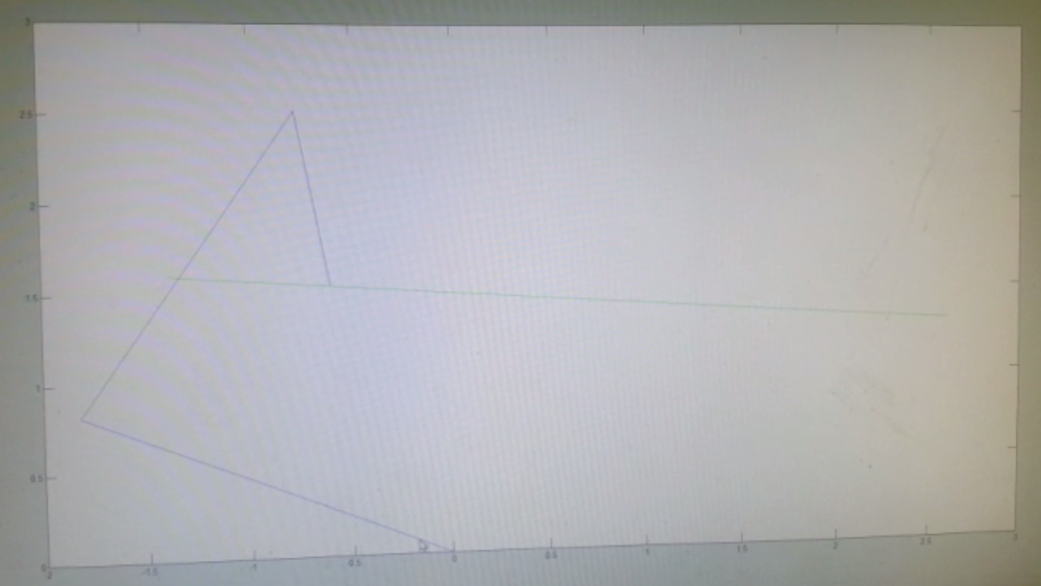

Part b)
In order to account for joint limits and collisions we implemented the following changes: For each of the joint positions we calculated the field potential in order to figure out the gradient around them. If they got within a minimum threshold distance from an obstacle, this kicked it and directed the joint away from the obstacle.

We implemented two simulations of two different obstacles in order to demonstrate the effectiveness of our obstacle avoidance. These can be found in video files “3b video 1.mp4” and “3b video 2.mp4”

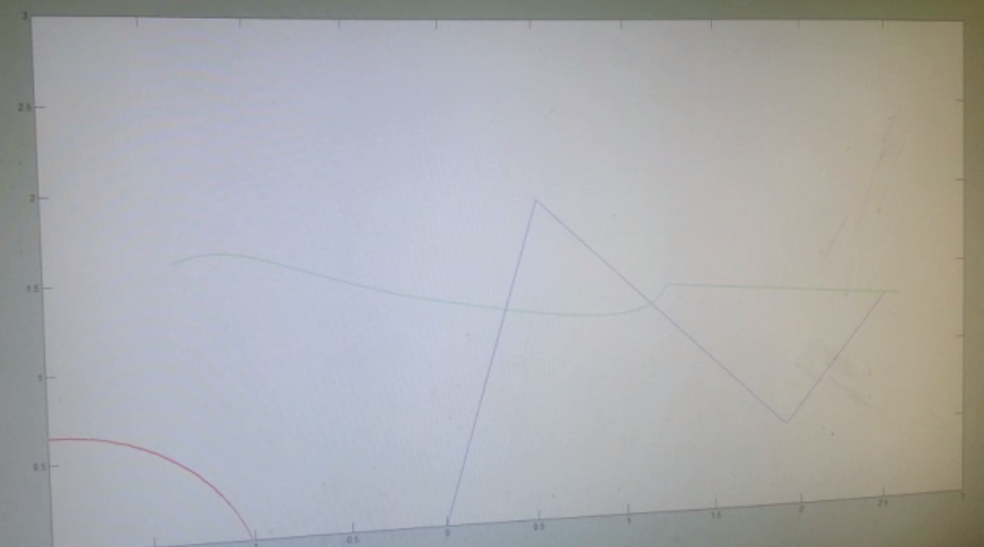
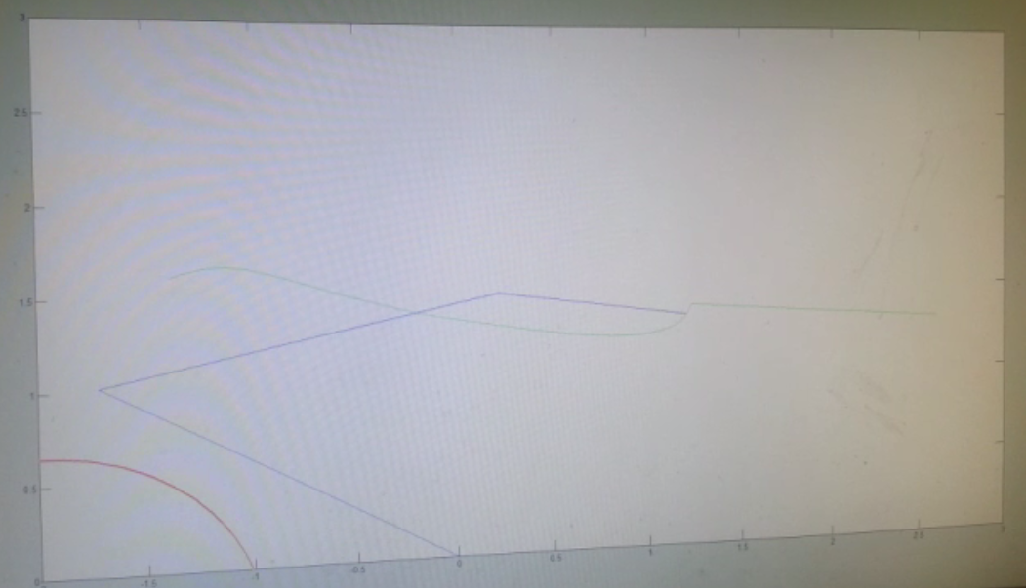

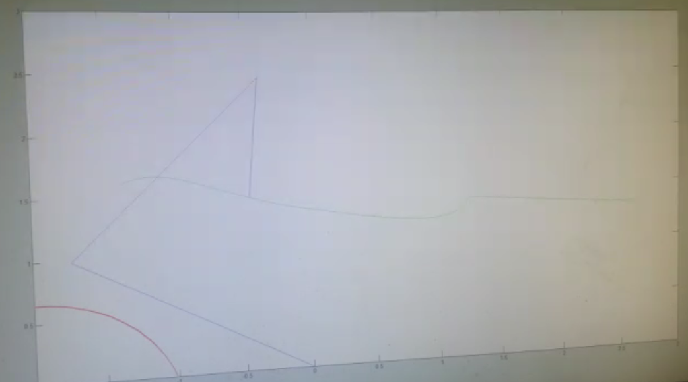
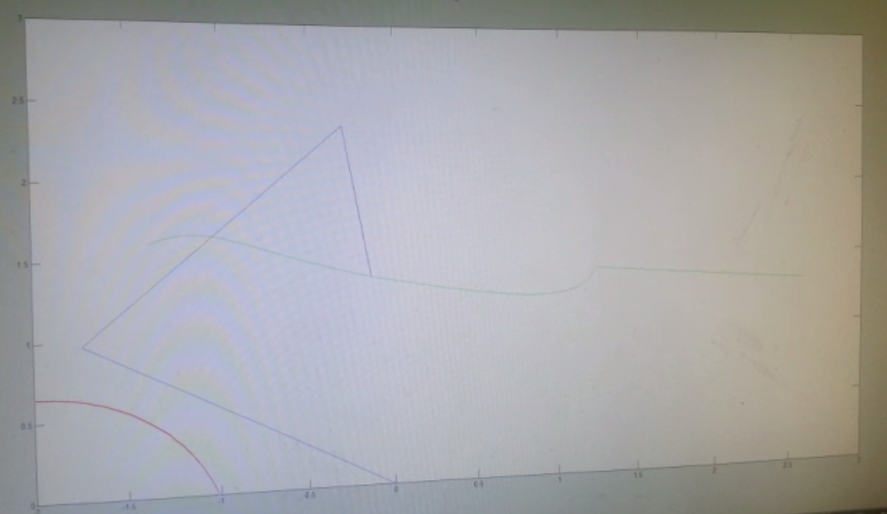
Video 2 for Problem 3 part B

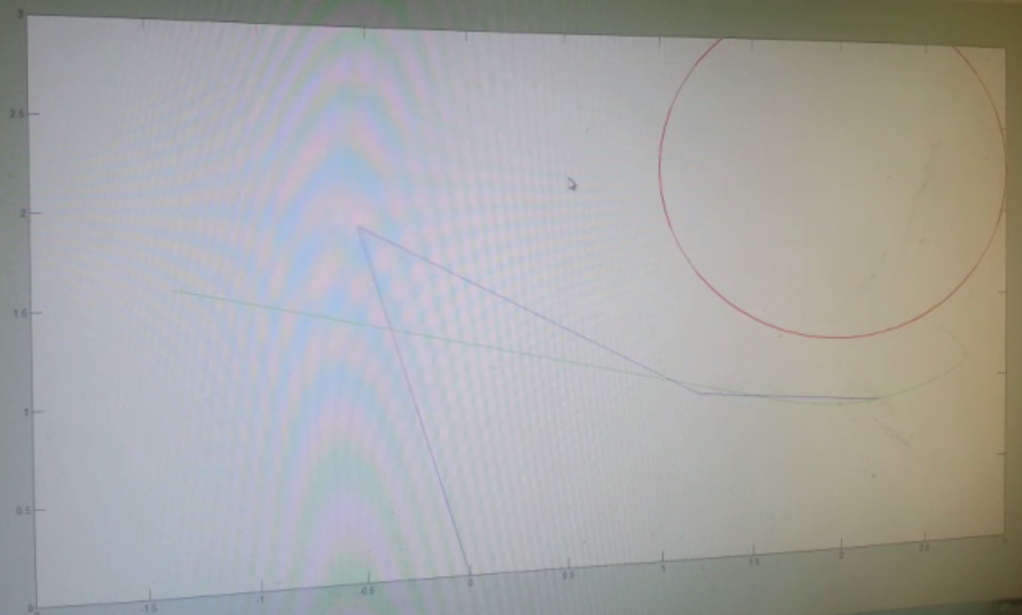
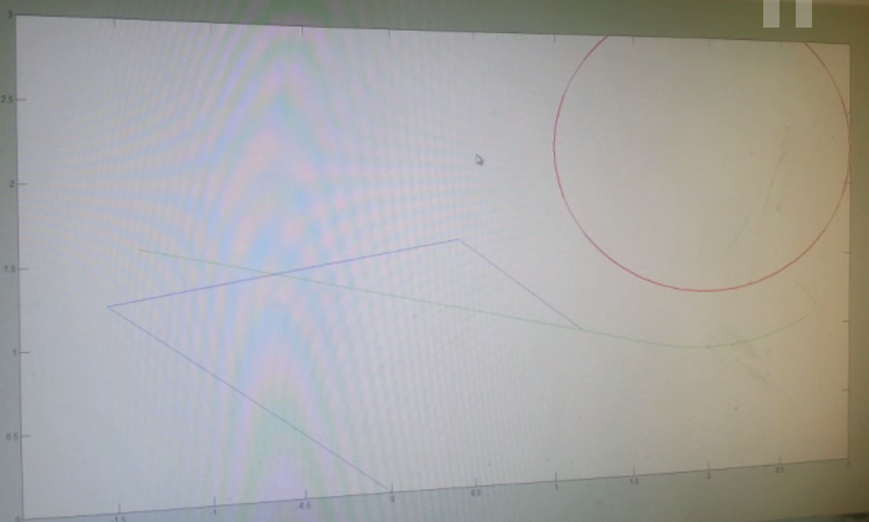
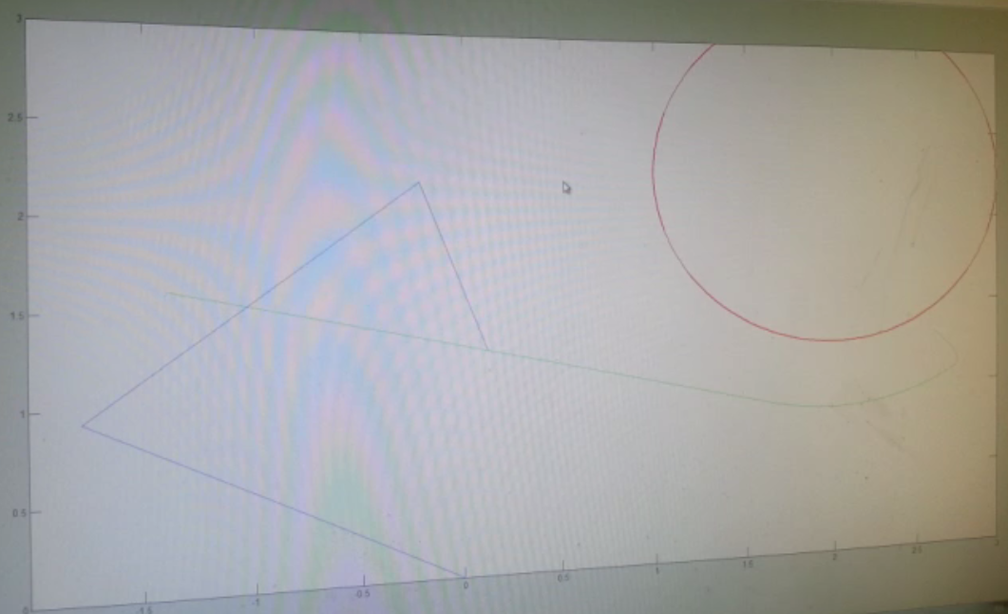
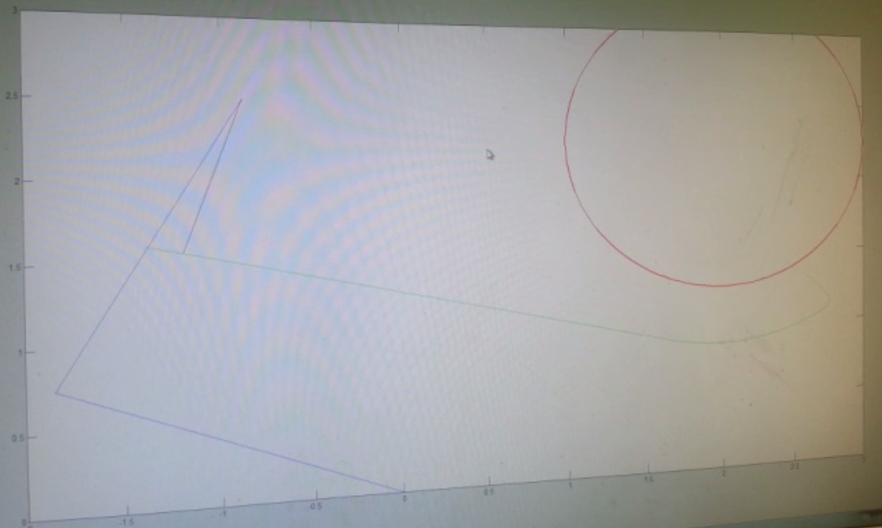
Question 4: Manipulation Planning – RRTs
Part a) This is a series of images chronicling the process of RRT generation without obstacles.
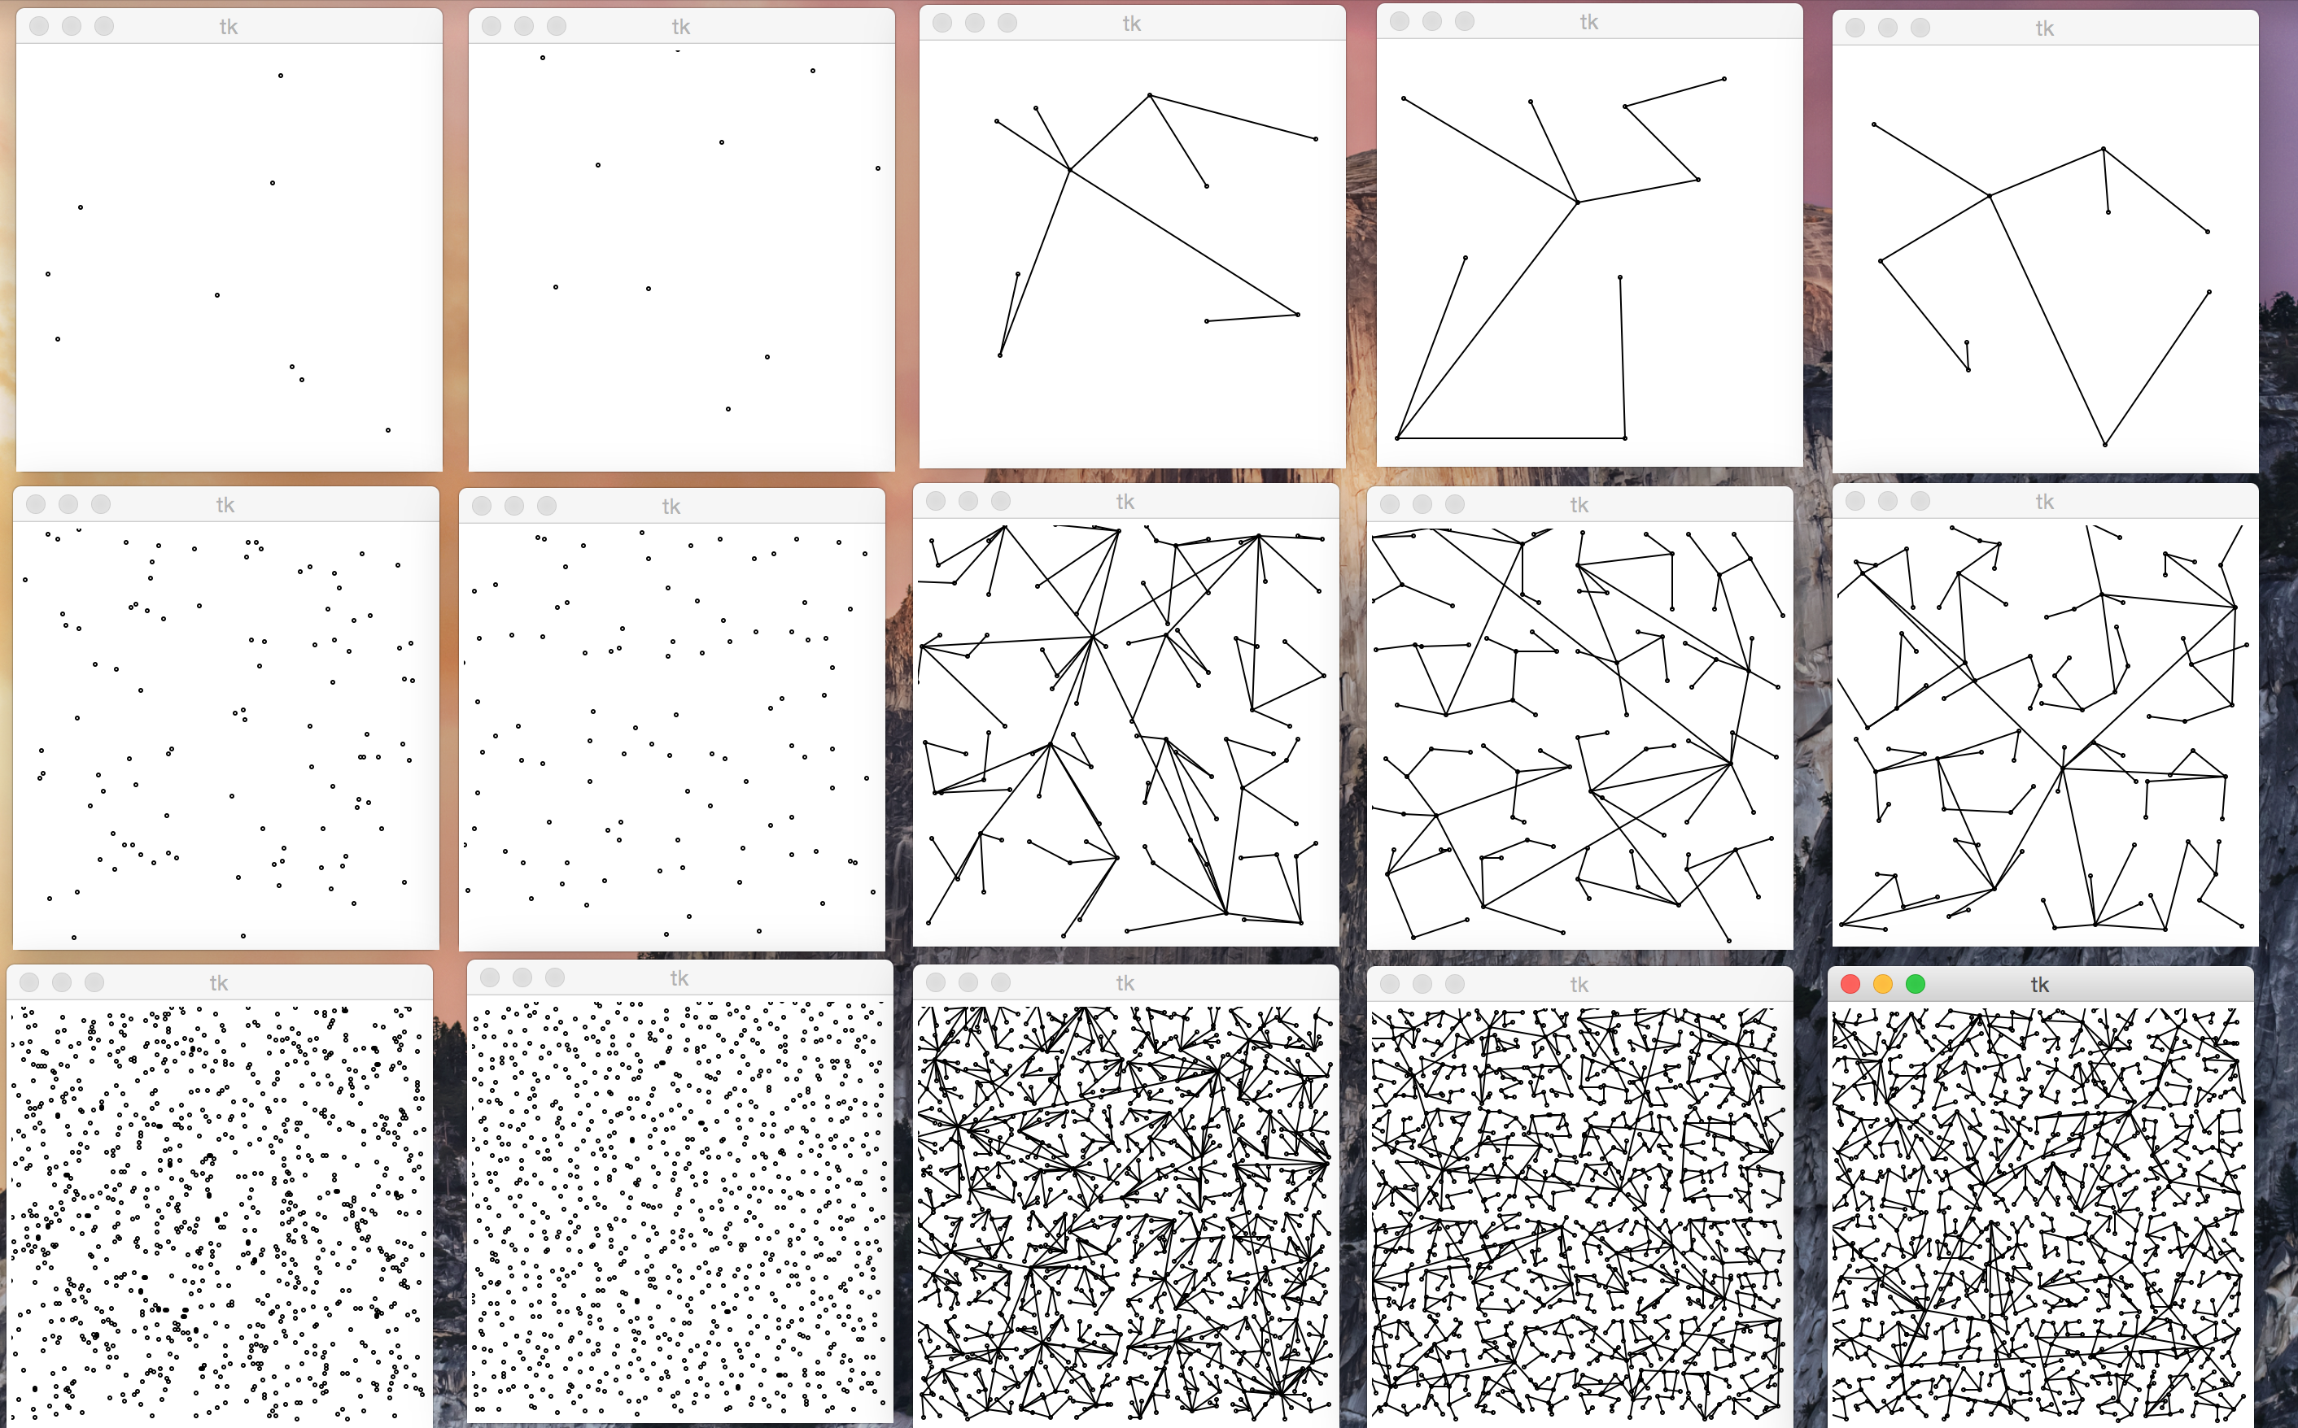

We were able to implement a rough version of the goal-directed approach along with the baseline approach. We were however unable to implement the remaining approaches. For the purpose of this analysis, we will do our best to approximate performance given what we observed. As the goal directed approach had a fewer number of nodes expanded along with fewer states observed (due to the heuristic using the goal) it was far better than the baseline. We personally feel that that the goal-directed approach will perform better than the connect or bidirectional approach because of nodes expanded and complexity however we were unable to complete these two implementations. Based on what we have completed however, goal directed is far better than the baseline approach for obvious reasons. In terms of variables that made the biggest difference in this section, we feel that it is the RRT step size. The RRT step size takes longer, but it is more likely to find the goal, and we feel that this is one of the deciding factors in the result and efficiency of the algorithm.

Question 5: Manipulation Planning - RRT with Task Constraints

Below is an image of our algorithm running. To finish this task, we essentially treat the vector between the end effector and the origin as the radius to a circle. We then add a corrective value to Q1 so that our value is on the constraint line. This algorithm is performed over and over, iteration by iteration until the algorithm converges and the goal is reached.
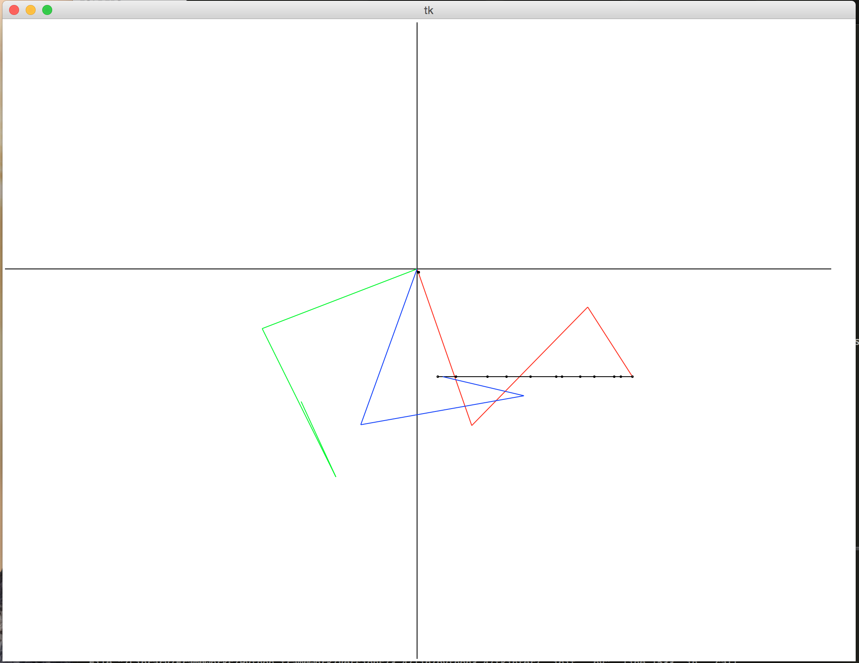
Contributions:

Sagar – Worked on all animations and worked on the theory for Problem 3. Worked to edit and finish paper.

Richard – Developed Problem 2 and handled the writeup of results and screenshot collection.

James – Spearheaded development for Problems 1 and 3 and worked on the theory for 4 – 5.

Ajmal – Lead program development for Problem 4 – 5.

Inder – Handled generation of the videos and assisted in program debugging

